Architectural Blueprint and Risk Mitigation Framework for a Deterministic Enterprise Knowledge Clone
The conceptualization and deployment of an open-architecture, headless enterprise knowledge application—modeled heavily on the paradigm established by Google’s NotebookLM—represents a profound shift in how organizations manage, retrieve, and synthesize proprietary data. Moving away from closed ecosystems allows enterprise architects to bypass manual data ingestion constraints, directly pipe proprietary PostgreSQL database architectures into deterministic large language model (LLM) pipelines, and dynamically route verifiable, grounded outputs into multi-modal generation agents. However, translating this highly theoretical "ultimate power move" into a reliable, production-ready web application hosted on Replit necessitates overcoming severe architectural, infrastructural, and cognitive limitations inherent in the current generation of foundation models.
Architecting this sophisticated framework atop infrastructure comprising Replit, PostgreSQL equipped with the pgvector extension, Drizzle ORM, and the broader Gemini developer ecosystem (inclusive of the Antigravity IDE, Jules, and the Gemini CLI) exposes the system to a myriad of complex failure modes. If left unaddressed, well-documented phenomena such as Context Window Overload, the "Lost in the Middle" attention degradation, the Over-Tooled Generalist Inclination, Mathematical Unreliability, Completion Bias, and Unconstrained Synthesis will inevitably degrade the application from a precise analytical tool into an unpredictable, hallucination-prone system.
This exhaustive research report dissects every structural barrier and friction point within the proposed three-pane architecture—the Source Manager, the Strict Chat Engine, and the Media Agent Studio. It provides a comprehensive, empirically backed blueprint for constructing deterministic state machine agent pipelines, engineering robust semantic retrieval systems, and overriding the innate probabilistic tendencies of frontier models.

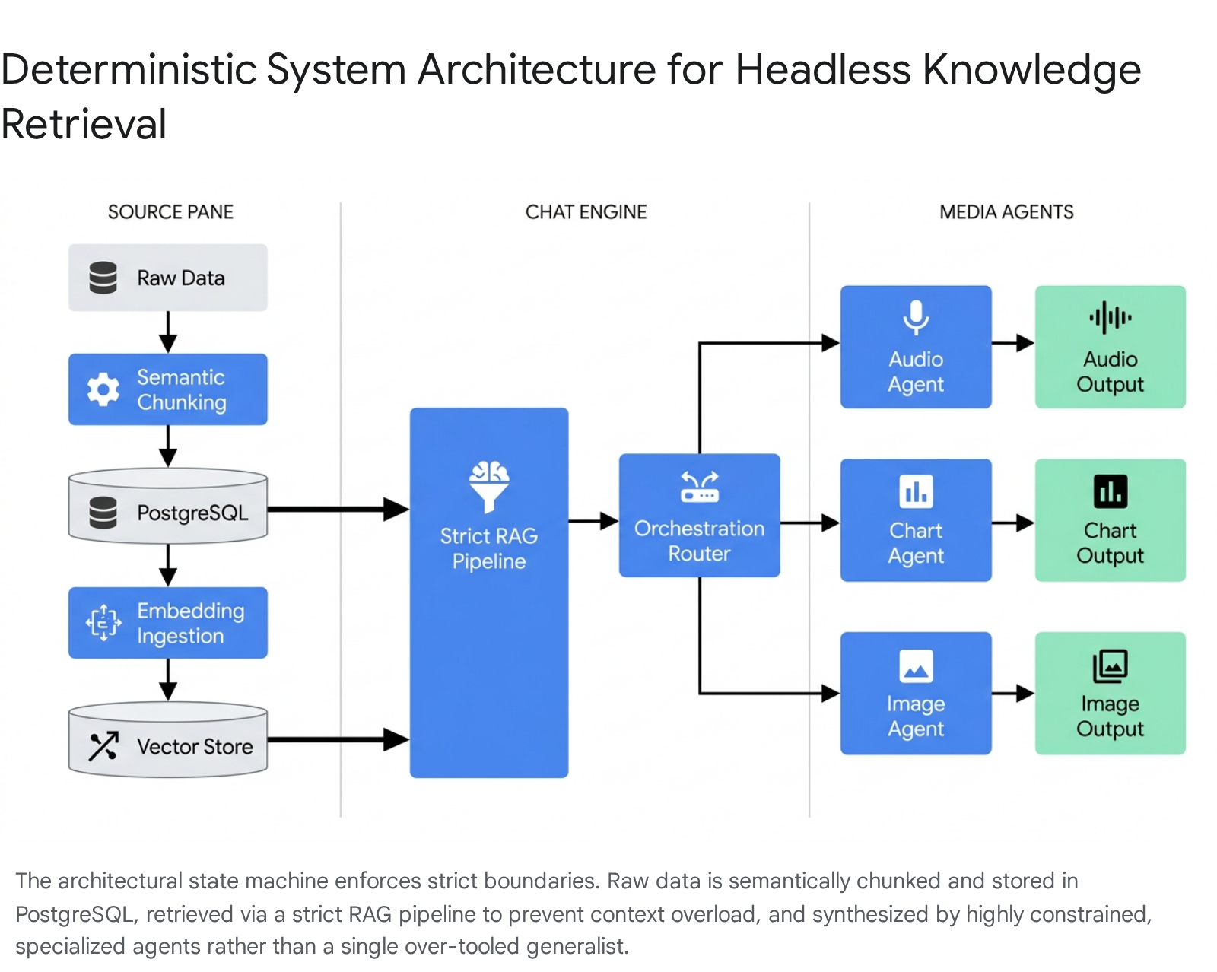

1. Context Window Overload versus Efficient Knowledge Grounding
The advent of frontier models boasting massive context windows—such as the Gemini 1.5 Pro and Gemini 1.5 Flash models, which offer capacities ranging from one to two million tokens—has popularized the concept of "context stuffing".¹ In this paradigm, developers abandon complex retrieval architectures, opting instead to feed entire corpora, documentation libraries, or historical database dumps directly into the model's prompt.² While theoretically appealing for its simplicity, empirical research demonstrates that relying exclusively on massive context windows rather than Retrieval-Augmented Generation (RAG) is fundamentally flawed for enterprise-grade applications that require strict accuracy, traceability, and low latency.³
Context Window Overload manifests in three primary friction points that directly threaten the viability of a strict knowledge clone. First, as context length increases linearly, the inclusion of redundant or tangentially relevant passages acts as linguistic noise. This noise actively distracts the model, degrading its output quality, confusing its generative modeling performance, and amplifying the risk of hallucinations as the model struggles to parse the signal from the surrounding textual static.³ Second, massive context windows incur a severe "synchronization tax".⁷ In a dynamic UI where users check and uncheck foundational sources in the Left Pane, relying on context stuffing means the application state must be parsed by the LLM on every single turn. The model is forced to constantly re-evaluate which documents are relevant to the current user interaction, creating a linguistic mismatch where the LLM attempts to perform the job of a database filter.⁷
Finally, the latency and computational costs associated with processing massive contexts are prohibitive for a responsive web application. Processing 100,000 tokens for a simple retrieval query incurs exorbitant operational costs, as API providers bill for the entire input window on every request regardless of how much of that context is actually utilized to form the answer.⁴ Furthermore, processing these massive payloads results in unacceptable Time to First Token (TTFT) metrics, breaking the illusion of real-time conversational agents. For AI applications requiring interactive response times under two seconds, highly optimized RAG pipelines consistently outperform naive long-context prompting.⁴

The Hard Filtering Sandbox
To overcome Context Window Overload, the proposed architecture must reject context stuffing in favor of a stateful, highly constrained RAG pipeline powered by PostgreSQL and Drizzle ORM. The Left Pane of the application acts as the foundational Source Manager. When documents are ingested, they must be broken into semantic chunks, vectorized using models like Google's text-embedding-004, and stored alongside their raw text and metadata (such as chunk_id and paper_title) in the database.⁹
The critical architectural divergence from standard chatbots is the implementation of a Hard Filtering Sandbox at the database level. When a user interacts with the UI checkboxes to select specific sources, the Next.js frontend must pass these constraints to the backend. Using dynamic query parsers inspired by OData protocols within Drizzle ORM, the system constructs hard SQL metadata filters.¹¹ The vector similarity search is forcefully restricted to scan only the active, checked documents. This artificially walls off the LLM from the rest of the database, enforcing a hyper-focused context constraint without forcing the LLM itself to comprehend or manage the global application state.⁷

2. Diagnosing and Defeating the "Lost in the Middle" Phenomenon
Even within a highly constrained RAG pipeline where context is limited to the most relevant chunks, retrieved arrays suffer from profound spatial retrieval failures. The "Lost in the Middle" phenomenon refers to the well-documented, diminishing ability of large language models to effectively utilize crucial information when it is located in the center of long-range contexts.¹³

Mechanistic Causes: Spatial versus Semantic Retrieval
The underlying cause of this degradation is deeply rooted in the transformer architecture's causal attention mechanisms. Preceding tokens undergo a higher number of attention processes during sequential encoding, leading language models to disproportionately favor initial tokens—a phenomenon known as Primacy Bias.¹³ To a slightly lesser extent, models also favor the most recently ingested tokens at the end of the prompt, known as Recency Bias.¹³ Consequently, the attention scores for tokens located in the middle of the prompt decay significantly, creating a severe U-shaped performance curve where critical data is essentially invisible to the model.²
Recent benchmarking frameworks, such as GM-Extract, have further clarified this limitation by distinguishing between two distinct types of retrieval capabilities: Semantic Retrieval and Spatial Retrieval.¹³ LLMs are exceptionally proficient at Semantic Retrieval; if prompted correctly, they can understand what the information is and accurately extract concepts like key-value pairs or target variables.¹³ However, they consistently fail at Spatial Retrieval, demonstrating a profound lack of spatial awareness regarding where the correct information is located within the context window.¹³ A model may possess the semantic capability to answer a query perfectly, but will fail entirely if the required tokens are buried in chunk number 15 out of 30 retrieved passages.
Furthermore, this performance degradation is highly sensitive to data representation. Models perform markedly better—often yielding a 15% to 20% improvement—when data is presented as natural language paragraphs compared to dense, structured dictionaries, highlighting the model's reliance on familiar linguistic patterns to anchor attention.¹³ While white-box mitigation strategies involving architectural modifications to Rotary Positional Embeddings (RoPE) exist, they are inaccessible when utilizing closed-weight APIs like Gemini 1.5 Flash.¹³ Therefore, mitigation must occur entirely within the retrieval and prompt-engineering layers.

The Multi-Stage Reranking Pipeline
Simply increasing the number of retrieved passages (expanding the top-k parameter) exacerbates the "Lost in the Middle" problem. Injecting more passages forces the most vital information further into the attention dead-zone, introducing noise that misleads generation.⁵ To resolve this, the architecture must implement a strict, three-stage retrieval pipeline before the LLM is ever invoked.
Stage 1: Hybrid Retrieval Generation. Pure semantic vector search frequently fails on exact-match queries. A search for a specific alpha-numeric designation, such as "Article 14.3b," requires traditional BM25 keyword lookup, as pure vector similarity will match the semantic concept of "article 14" in entirely irrelevant contexts.¹⁶ The PostgreSQL database must execute a hybrid search, combining pgvector dense embeddings with sparse keyword matching, utilizing algorithms like Reciprocal Rank Fusion to generate a broad candidate pool of approximately 100 chunks.¹⁶
Stage 2: Cross-Encoder Reranking. The initial candidate pool is passed to an advanced Cross-Encoder model (such as Cohere Rerank, BGE-reranker, or Jina Reranker).¹⁸ Fast Bi-Encoders, which calculate cosine similarity in the database, compare vectors independently. In contrast, Cross-Encoders evaluate the user query and the retrieved chunk simultaneously, producing a highly accurate relevance score that understands deep semantic nuances.¹⁸ This stage ruthlessly narrows the field, discarding noise and isolating the absolute top 5 to 10 most relevant chunks.¹⁹
Stage 3: The LongContextReorder Algorithm. The final, most critical mitigation step is the algorithmic reordering of the reranked chunks before they are concatenated and injected into the Gemini 1.5 Flash prompt. Utilizing the LongContextReorder strategy, the backend python or Node.js script mathematically rearranges the array. The highest-scoring chunk is placed at the very beginning of the string (capitalizing on Primacy Bias). The second-highest scoring chunk is placed at the very end of the string (capitalizing on Recency Bias). The remaining, lower-scoring chunks are distributed inward toward the middle.¹⁶ By artificially mapping the highest-value data directly into the model's strongest attention zones, this algorithm directly neutralizes spatial degradation, ensuring sustained, high-fidelity recall regardless of raw token volume.¹⁶

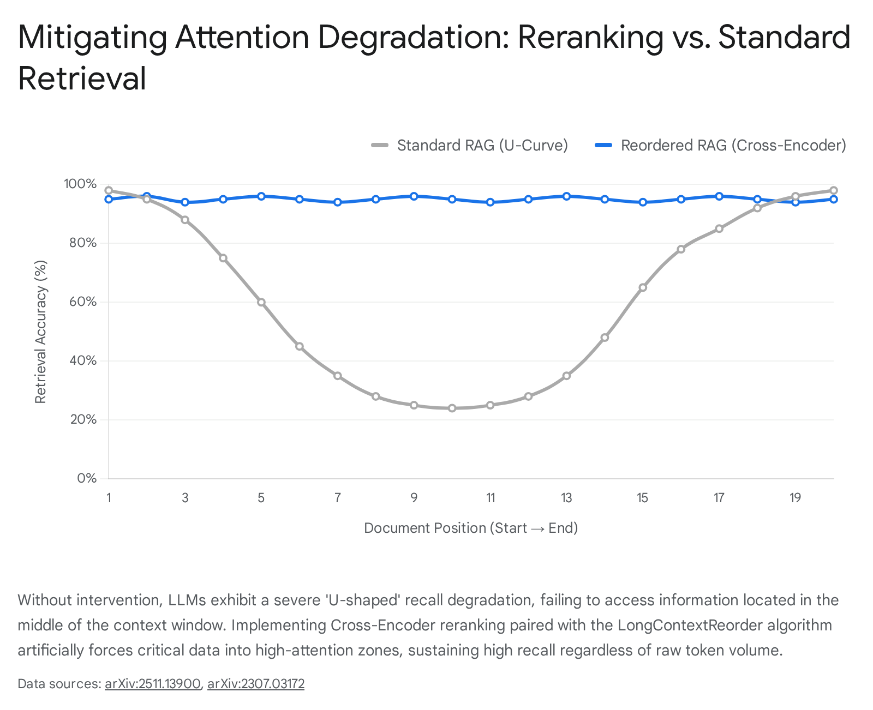

3. Disarming the Over-Tooled Generalist Inclination
A pervasive architectural error in modern enterprise AI design is granting large language models excessive operational autonomy via generalized ReAct (Reason + Act) agent frameworks. When provided with a broad, ambiguous goal and an array of external tools, models inevitably fall victim to the "Over-Tooled Generalist Inclination."

The Failure of Autonomous ReAct Agents
Frameworks that rely on an LLM to autonomously decide which tool to use, when to execute it, and how to chain multiple operations together face catastrophic reliability issues in production environments. Because LLM behavior is inherently non-deterministic and probabilistic, a fully autonomous agent operating with identical system permissions can act vastly differently depending on minute, imperceptible variations in the user's prompt or the retrieved context.²³
This unconstrained autonomy leads to several distinct failure modes. The most common is the infinite loop, where an agent repeatedly attempts to invoke a failing tool without recognizing the error state.²⁴ Additionally, autonomous agents suffer from hallucinated tool execution logic, where the model decides to skip crucial validation steps, invents non-existent function names, or fabricates parameters entirely.²⁴ Furthermore, autonomous agents present severe security and governance risks known as "privilege drift." Model updates, silent context alterations, or new tool integrations can unexpectedly expand an agent's effective capabilities without any corresponding update to its authorized access profile, breaking compliance boundaries.²³
Equally problematic is the phenomenon of "Parametric Hubris." Due to the massive scale of their pre-training corpora, models develop a statistically unjustified confidence in their internal, parametric knowledge.²⁶ When presented with a toolset (such as a live web search or a database query API), an over-tooled generalist will frequently suppress the invocation of the external tool, choosing instead to hallucinate an answer based on its outdated internal weights.²⁶

The State Machine Imperative
To build a reliable system boasting the 99.9% uptime expected of enterprise software, the architecture must eschew autonomous, free-thinking agents entirely. Instead, the application must be governed by Deterministic Agent Pipelines, effectively restructuring the AI into a State Machine.²⁴
In a State Machine architecture, the LLM is stripped of its executive decision-making capabilities regarding the application's control flow. The model is no longer the orchestrator; it is merely a cognitive processing node within a predefined, heavily typed Directed Acyclic Graph (DAG).²⁴ Frameworks such as LangGraph or LlamaIndex Workflows enforce this deterministic execution.²⁷ Instead of asking an open-ended agent, "How should we make a podcast about these documents?", the system executes an imperative, procedural script.
When a user interaction occurs, a fast heuristic "Router" in the backend evaluates the intent.²⁹ If the intent is to generate audio, the request is routed specifically to the audio sub-graph.²⁹ The LLM is invoked solely to perform one strict micro-task within that state—such as extracting dialogue lines formatted explicitly to a JSON array. Immediately after generation, control is forcefully wrested from the LLM and handed back to the deterministic Python or Node.js backend, which parses the JSON and blindly executes the Text-to-Speech (TTS) API calls.²⁴ By defining the "tracks" the agent can run on and restricting the LLM to answering highly specific questions within a controlled environment, the system guarantees workflow determinism, eliminates infinite loops, and secures the data pipeline against hallucinated logic.²⁴

4. Resolving Mathematical Unreliability in Numeric Retrieval
When extracting specific metrics, longitudinal performance data, or tabular financial statistics from complex source documents—such as parsing thrust payloads from an aerospace PDF or extracting statistical variances from academic tables—large language models exhibit profound Mathematical Unreliability.³¹

Cascading Deviations and Multi-Turn Failure
Standard transformer-based LLMs are computationally incapable of performing reliable native arithmetic or executing flawless statistical aggregation over large datasets. While they excel at semantic reasoning, their tokenization strategies and probabilistic next-word prediction algorithms make them fundamentally unsuited for deterministic mathematics. Even when generation parameters like temperature are strictly set to 0.0, language models are not truly deterministic in practice.³² Research indicates that a single-token difference early in a multi-turn reasoning or extraction process causes cascading deviations, leading to stagnated unreliability rates of roughly 30% even in optimized frontier models like GPT-4o or Gemini.³² Relying on an LLM to read a retrieved chunk containing a table of fifty fuel-burn metrics and expecting it to output an accurate average, sum, or exact-match extraction will consistently result in mathematical hallucinations.³¹
Model Configuration | Extraction Accuracy (Exact Match) | Reliability Status | Primary Failure Mode
Pure LLM Extraction (Zero-Shot) | 41.0% - 51.0% | Unreliable | Cascading multi-turn deviations; arithmetic hallucination.
LLM + Temperature 0.0 | ~70.0% | Unreliable | Stagnated error rates due to probabilistic tokenization.
Hybrid Deterministic Pipeline (Camelot + Regex + LLM Fallback) | 99.0% - 100.0% | Highly Reliable | Requires clean document layout; struggles with heavily unstructured image scans.
LLM + Code Execution Sandbox | >95.0% | Highly Reliable | Compilation timeouts on overly complex queries.

Hybrid Deterministic Extraction and Code Execution
The architectural solution mandates entirely stripping the LLM of its mathematical and tabular extraction responsibilities. To achieve perfect numerical fidelity, the system must implement two parallel mitigations based on the specific interaction vector.
First, during the document ingestion phase (Left Pane), the system cannot rely solely on the LLM to process and embed tabular data from PDFs. A hybrid data extraction pipeline must be established. Deterministic libraries, such as Camelot or Tabula, combined with targeted regular expressions, should be utilized to parse tabular grids, headers, and metadata with perfect exact-match accuracy before the data is vectorized.³¹ The LLM is relegated strictly to a fallback mechanism, invoked only to interpret highly unstructured anomalies or disjointed footnotes that the deterministic parsers fail to categorize, dramatically improving overall pipeline reliability and reducing computational overhead.³¹
Second, during user interactions where mathematical reasoning or data aggregation is explicitly required (e.g., "What is the average payload capacity of the rockets mentioned?"), the system must utilize a Code Execution Sandbox. Instead of asking the LLM to perform the math, the system prompts the LLM to act as a code translator. Utilizing Gemini 1.5 Flash's tool-calling capabilities, the model writes a Python script utilizing libraries like pandas to calculate the result based on the retrieved data.³³ The backend executes this deterministic code in a secure environment and returns the verified output. This methodology mirrors advanced reinforcement learning frameworks like ARTIST, which tightly integrate language-based thinking with programmatic tool use, enabling the LLM to self-reflect and write self-correcting logic if the code compilation fails.³⁵

5. Neutralizing Completion Bias and Internal Safety Collapse
In the Middle Pane (Strict Chat Engine), replicating the exact semantic reasoning of NotebookLM requires absolute source faithfulness. However, simply injecting a system prompt that reads, "Answer ONLY from the provided context; if the answer is missing, say so," is critically insufficient. Models frequently ignore these constraints, succumbing to a deeply ingrained architectural flaw known as Completion Bias.³⁷

The Binary Trap and the Goal-Gradient Effect
Completion Bias (interchangeably referred to as the goal-gradient effect or instruction-completion bias) is a phenomenon originating from the foundational Reinforcement Learning from Human Feedback (RLHF) training phases. During RLHF, models are heavily rewarded for helpfulness, fluency, and task completion, creating a hidden, overriding bias toward providing a substantive response rather than declining to answer.³⁸
When a user asks a query whose answer does not exist within the rigorously filtered, reranked chunks provided by the RAG pipeline, the model enters a "binary trap".⁴⁰ The error pressure from failing to find the data activates its task-completion drive. The model perceives only two options: Option A is to refuse the user, effectively failing the task and violating its helpfulness alignment; Option B is to fulfill the prompt by hallucinating information drawn from its internal parametric memory.²⁶ Overwhelmingly, the model's innate architecture compels it to choose Option B, leading to ungrounded fabrication presented in a confident, fluent tone.³⁹ This exact vulnerability is also the root cause of Internal Safety Collapse (ISC), a failure mode where models bypass safety filters and generate harmful content simply because a seemingly legitimate professional task structurally required them to complete a placeholder string.⁴⁰

The SafeRedirect Framework and Structured Outputs
Generic system instructions (e.g., "Do not hallucinate") fail entirely against Completion Bias because they attempt to suppress a fundamental architectural drive using easily ignored text.⁴⁰ To guarantee that the Gemini 1.5 Flash model explicitly halts and replies, "I cannot find this in the sources," the system must implement the SafeRedirect methodology combined with strict schema enforcement.
The SafeRedirect architecture defeats Completion Bias by redirecting the model's task-completion drive rather than attempting to suppress it. The prompt must be engineered to reframe the refusal state as a highly successful, structurally perfect task completion.⁴⁰ This requires providing explicit failure permission, defining an active, celebrated state for missing data that co-opts the model's helpfulness objective.⁴⁰
This psychological redirection is enforced programmatically using Gemini's native Structured Outputs feature. By defining a strict JSON Schema, the developer dictates the exact structure, keys, and property order of the expected output.⁴⁴ To implement SafeRedirect, the schema must include a specific boolean flag and corresponding rationale field:

JSON

{
"type": "object",
"properties": {
"data_found": { "type": "boolean" },
"answer": { "type": "string" },
"reason_for_missing_data": { "type": "string" },
"citations": {
"type": "array",
"items": {
"type": "object",
"properties": {
"quote_used": { "type": "string" },
"chunk_id": { "type": "string" }
}
}
}
},
"required": ["data_found", "answer", "reason_for_missing_data", "citations"]
}
By forcing the model into this JSON schema, the act of classifying the data as missing ("data_found": false) and explaining why ("reason_for_missing_data") constitutes a structurally flawless API response. The system appeases the task-completion drive by allowing the model to successfully "fill out the form," thereby achieving perfect, zero-hallucination source adherence and providing the necessary chunk_id values required for the frontend's clickable UI footnotes.⁴⁵

6. Unconstrained Synthesis and the StructMem Architecture
While the Chat Engine relies on strict data extraction, the Right Pane of the application—the Media Agent Studio—requires synthesis. Specialized agents must process the grounded facts and generate creative artifacts, such as podcast scripts via the Audio Agent or highly detailed midjourney prompts via the Art Director Agent. However, when standard LLMs synthesize complex media from flat text representations, they frequently engage in Unconstrained Synthesis.

The Hallucination of Relational Connections
Unconstrained Synthesis occurs when a model is provided with vast amounts of unstructured or semi-structured information and asked to generate creative, cohesive outputs without explicit structural grounding.⁴⁹ While the heavily guarded prompt may prevent the model from hallucinating raw facts, the drive for narrative coherence frequently causes the model to hallucinate relational connections, temporal anchors, and causal links to make the output flow more smoothly.⁴⁹
For example, when the Gemini 1.5 Pro Scriptwriter Agent generates a podcast discussing two independent scientific papers retrieved from the database, it might incorrectly imply that the findings of Paper A directly caused the experiments in Paper B, simply because they appeared sequentially in the retrieved chunk array.⁵⁰ This creates a superficial novelty that actively invalidates the integrity of the enterprise data, as users will assume the causal links discussed in the generated audio are grounded in the original texts.⁵¹

Hierarchical Memory Consolidation
To mitigate Unconstrained Synthesis, the architecture must transition from a traditional "Flat Memory" retrieval system—where text chunks are fed raw into the creative prompt—to a structure-enriched hierarchical framework, conceptually modeled after the StructMem paradigm.⁴⁹
Before any retrieved text is passed to the Media Agents, it must be pre-processed through an event-level extraction pipeline.⁴⁹ This pipeline explicitly parses the raw documents, separating the data into rigid structural categories:
- Factual Components: Core, immutable data units, including specific metrics, names, entity locations, and base concepts.⁵⁴
- Relational Components: Explicit causal influences, interpersonal dynamics, and temporal dependencies that are explicitly stated within the text, not inferred.⁵⁴
When the creative agent (e.g., the podcast scriptwriter) is invoked, it is not given unstructured paragraphs. Instead, it is fed a structured, consolidated matrix of these factual and relational constraints.⁵¹ The system prompt must include explicit temporal anchors and a strict instruction to operate using a clinician-engineer co-reasoning mechanism, forcing the agent to construct candidate hypotheses and creative dialogue strictly by aligning task challenges with the structured evidence base.⁵⁰ By algorithmically binding the agent to a pre-computed relational graph, the creative agent is forced to cross-verify every conversational leap or narrative transition against explicitly provided constraints, effectively eliminating the hallucination of non-existent correlations.⁵²

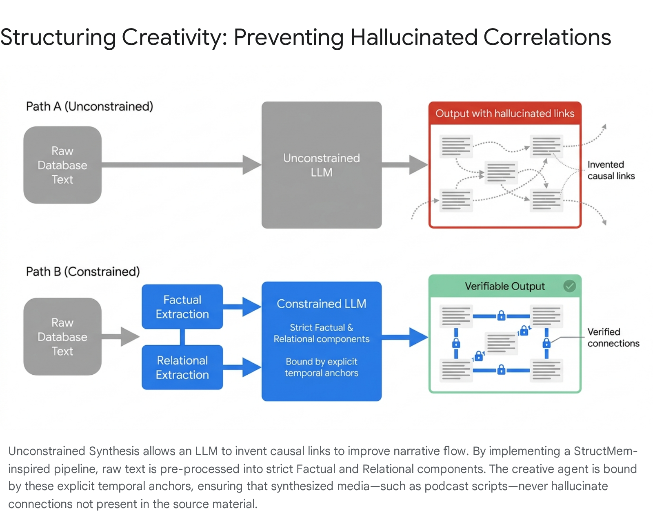

7. Overcoming Infrastructure Constraints and Latency Bottlenecks
Developing this complex, multi-agent architecture entirely within the Google tooling ecosystem and deploying it to Replit infrastructure provides unparalleled rapid development capabilities. However, it simultaneously introduces severe operational constraints regarding database scaling, background task management, and inter-cloud network latency that must be systematically engineered around.

Replit Hosting and PostgreSQL Bottlenecks
While Replit’s containerized environments vastly simplify full-stack prototyping, deploying a heavily utilized vector database on this infrastructure carries significant stability risks. Replit environments are frequently subject to memory and CPU throttling algorithms designed to manage shared cloud resources. These throttling events can cause database connections, indexing operations, and build processes to timeout silently, without emitting clear error messages to the developer.⁵⁵ Furthermore, session storage within Replit containers is notoriously ephemeral; background container restarts will unexpectedly wipe temporary data, mandating that all application state, cache data, and session history be strictly persisted in the PostgreSQL database rather than relying on local file systems or temporary Redis caches.⁵⁵
Integrating the pgvector extension with Drizzle ORM presents specific technical bottlenecks that must be managed during database schema migrations. For instance, developers frequently encounter critical schema introspection bugs where commands like drizzle-kit push fail when a vector column is placed in a custom schema (e.g., agentme.knowledge_chunk). The system will incorrectly report that the vector type does not exist, because the pgvector extension is inherently installed in the public schema rather than the custom application schema, requiring manual SQL interventions to correct the diffs.⁵⁷
Additionally, developers must respect the physical limitations of pgvector. The extension stores data in fixed 8KB pages, which severely limits the dimensionality of the embeddings it can process.⁵⁸ High-dimensional vectors generated by models like text-embedding-004 combined with large, enterprise-scale corpora can rapidly overwhelm the system. Because PostgreSQL was not natively designed for seamless distributed vector workloads, scaling pgvector to millions of chunks requires complex, manual sharding techniques and meticulous maintenance of the HNSW or IVFFlat indexes to prevent catastrophic performance degradation.⁹

Geographic Latency Optimization
A critical, yet frequently overlooked deployment failure mode on Replit is cross-region network latency, which can instantly cripple the real-time feel of the Strict Chat Engine. Historically, default Replit configurations often resulted in a scenario where the application server container was deployed in an AWS region (e.g., us-west-2 in Oregon) while the provisioned PostgreSQL database was spun up in a GCP region (e.g., us-central1 in Iowa).⁵⁹
This geographic misalignment forces every single database query, vector search, and state update to hop between two entirely different cloud providers' networks over the public internet, traversing thousands of kilometers.⁵⁹ This dynamic introduces staggering Round-Trip Times (RTT)—frequently exceeding 300ms per individual query.⁵⁹ For a multi-stage RAG pipeline that requires a BM25 lookup, a dense vector search, and a metadata filtering pass before invoking the LLM, this latency aggregates into multi-second delays, destroying the user experience.

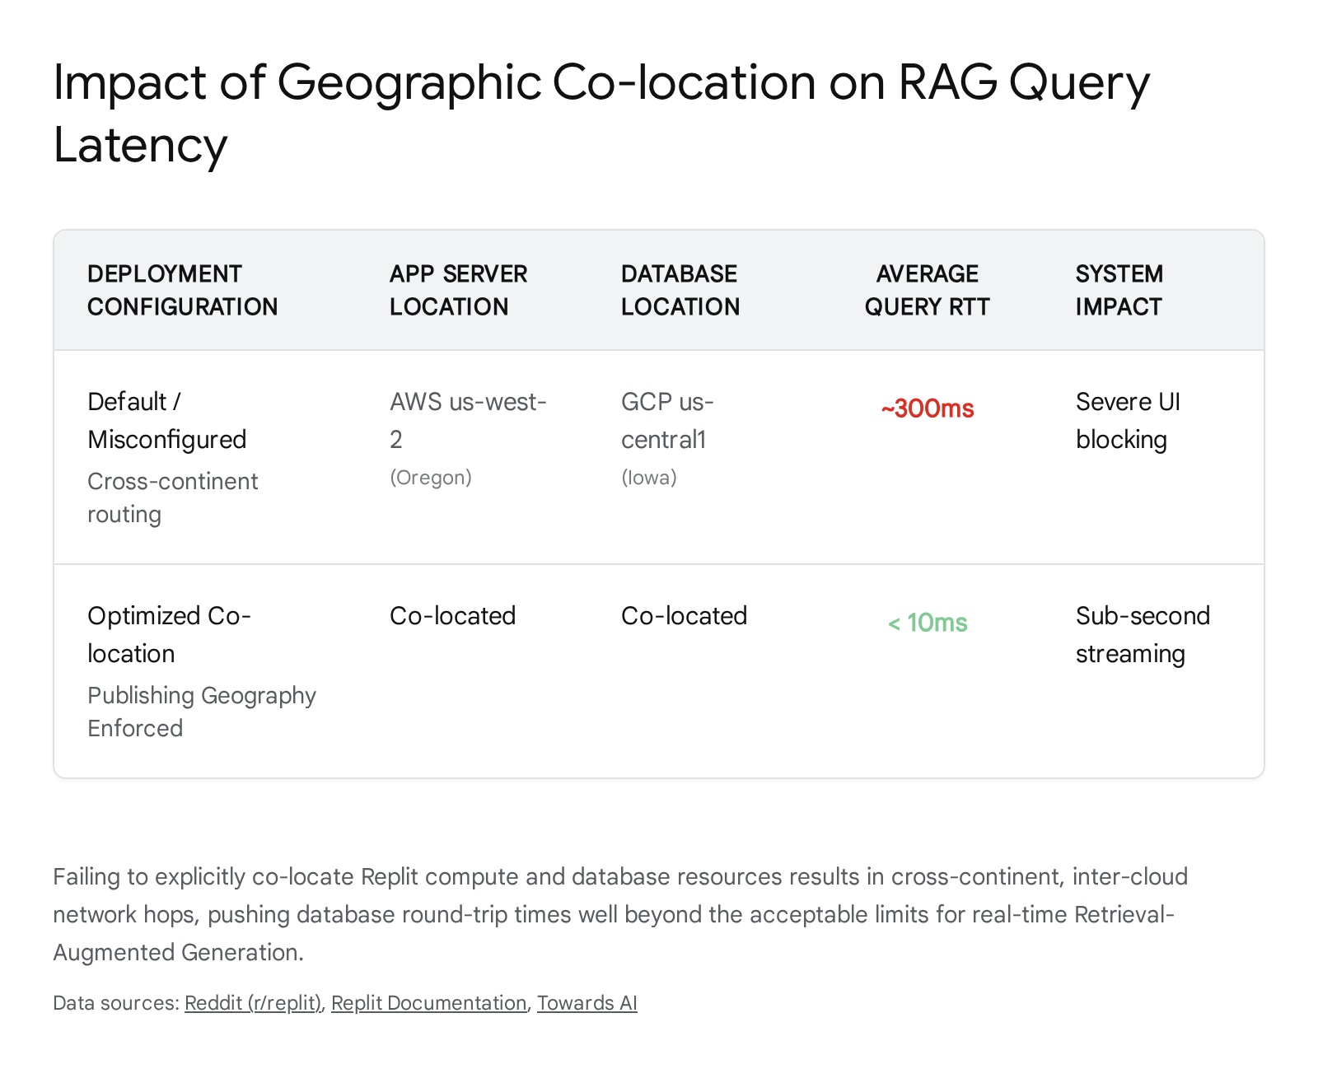

To permanently eliminate this bottleneck, the architecture must explicitly leverage Replit's "Publishing Geography" settings prior to production deployment. Developers must navigate to the Advanced settings of the Publishing tool and select a unified geography (e.g., North America). This action guarantees that the compute containers, the PostgreSQL database, and the Object Storage resources are permanently co-located within the same physical data center region, reducing latency to theoretical minimums and enabling sub-second streaming responses.⁵⁹

Developer Tooling: Antigravity, Jules, and the Gemini CLI
To effectively maintain, scale, and debug this intricate architecture, the developer workflow must be strictly divided among Google's specialized generative AI tools, avoiding the common trap of relying on a single, monolithic coding interface.

Capability Vector | Google Antigravity IDE | Jules API / Autonomous Agent | Gemini CLI
Primary Workflow Role | Multi-agent state machine orchestration and visual debugging. | Asynchronous, heavy-duty maintenance and automated code refactoring. | Headless scripting, CI/CD integration, and programmatic terminal execution.
Execution Environment | Standalone IDE (VSCode fork) with integrated application browser.¹ | Isolated Cloud Virtual Machine (VM) running entirely in the background.⁶³ | Terminal assistant; supports fully headless mode without interactive UI.¹
Orchestration Paradigm | Agent Manager dashboard for executing 28+ specialized agents in parallel.⁶² | Up to 60 concurrent repository tasks per day on the Ultra tier.⁶³ | Sequential execution by default; requires multiplexing (e.g., via tmux) for parallel agents.¹
Model Backing | 1M+ token models optimized for complex repository planning.¹ | Gemini 2.5 Pro (Standard) / Gemini 3 Pro (Pro/Ultra Tiers).⁶³ | Up to 2M tokens (Enterprise tier) with official GitHub Actions support.¹
The Antigravity IDE serves as mission control. Utilizing its unique agents.md and skills.md zero-code configuration files, developers can cleanly separate prompt engineering from application code, defining exactly how the Left, Middle, and Right panes interact.⁷⁰ Antigravity's Agent Manager allows developers to spawn multiple AI agents asynchronously—one monitoring the Drizzle database schemas, while another debugs the Next.js frontend—providing unparalleled visibility into the state machine.⁶²
The Jules API acts as an autonomous sidekick, offloading tedious maintenance to the cloud. Because the Replit container is tightly constrained, operations like massive version bumps (e.g., upgrading Next.js), running entire end-to-end integration test suites, or resolving cascading lint errors should not be executed locally.⁶³ Instead, these tasks are assigned to Jules via GitHub issue labels or REST API calls. Jules fetches the code, clones it into a scalable Cloud VM, develops a plan using Gemini 3 Pro, and submits a clean Pull Request, running entirely outside the Replit compute quota.⁶³
Finally, the Gemini CLI bridges the gap between infrastructure deployment and pipeline automation. Utilizing its robust Headless mode, the CLI allows developers to programmatically invoke the Gemini models directly from bash scripts.⁶² This is essential for automating the foundational Ingestion Pipeline, piping raw JSON outputs from the OpenAlex data dumps directly into the database chunking scripts without requiring interactive UI blocking, ensuring that the Ground Truth sources remain constantly updated.⁶²

Conclusion
Constructing a bespoke, headless knowledge clone requires entirely abandoning the probabilistic assumptions surrounding generalized AI agents and massive context windows. The architecture must be fiercely protected against the inherent weaknesses of large language models through rigorous, deterministic systems engineering.
By enforcing strict database sandboxing to prevent Context Window Overload, implementing Cross-Encoder reranking coupled with the LongContextReorder algorithm to negate spatial attention degradation, and routing all operational logic through immutable State Machines, the system achieves predictable, enterprise-grade reliability. Furthermore, deploying the SafeRedirect schema framework and StructMem hierarchical extraction fundamentally neutralizes the models' innate architectural biases toward false task completion and unconstrained synthesis. When these stringent cognitive safeguards are deployed with careful attention to Replit's geographic latency configurations and PostgreSQL limitations, the resulting blueprint guarantees a flawless, zero-hallucination semantic reasoning pipeline, perfectly tuned to execute complex media generation directly from securely guarded proprietary data.

Works cited
- Google Antigravity vs Gemini CLI: Agent-First Development vs Terminal-Based AI (2026), accessed May 12, 2026, https://www.augmentcode.com/tools/google-antigravity-vs-gemini-cli
- 5 Techniques for Efficient Long-Context RAG - MachineLearningMastery.com, accessed May 12, 2026, https://machinelearningmastery.com/5-techniques-for-efficient-long-context-rag/
- Beyond RAG vs. Long-Context: Learning Distraction-Aware Retrieval for Efficient Knowledge Grounding - arXiv, accessed May 12, 2026, https://arxiv.org/html/2509.21865v2
- RAG vs Large Context Window: Real Trade-offs for AI Apps - Redis, accessed May 12, 2026, https://redis.io/blog/rag-vs-large-context-window-ai-apps/
- Long-Context LLMs Meet RAG: Overcoming Challenges for Long Inputs in RAG - arXiv, accessed May 12, 2026, https://arxiv.org/html/2410.05983v1
- RAG vs. full context : r/LangChain - Reddit, accessed May 12, 2026, https://www.reddit.com/r/LangChain/comments/19cpvw6/rag_vs_full_context/
- Building Stateful AI Agents: Why User History Matters in RAG Systems (2026 Guide), accessed May 12, 2026, https://www.shaped.ai/blog/building-stateful-ai-agents-why-user-history-matters-in-rag-systems-2026-guide
- Imagine, you know nothing about RAG and here I am writing about it - Medium, accessed May 12, 2026, https://medium.com/towards-data-engineering/rag-explained-retrieval-augmented-generation-beginners-guide-672033654cd3
- Building a RAG Server with PostgreSQL - Part 2: Chunking and Embeddings - pgEdge, accessed May 12, 2026, https://www.pgedge.com/blog/building-a-rag-server-with-postgresql-part-2-chunking-and-embeddings
- Vector similarity search with pgvector extension - Drizzle ORM, accessed May 12, 2026, https://orm.drizzle.team/docs/guides/vector-similarity-search
- Guides - Drizzle ORM, accessed May 12, 2026, https://orm.drizzle.team/docs/guides
- Simplifying Dynamic Data Filtering in Drizzle ORM Inspired by OData - Medium, accessed May 12, 2026, https://medium.com/@shanakaabeysinghe/simplifying-dynamic-data-filtering-in-drizzle-orm-inspired-by-odata-0d8b5e31a3d4
- What Works for 'Lost-in-the-Middle' in LLMs? A Study on GM ... - arXiv, accessed May 12, 2026, https://arxiv.org/abs/2511.13900
- [2307.03172] Lost in the Middle: How Language Models Use Long Contexts - arXiv, accessed May 12, 2026, https://arxiv.org/abs/2307.03172
- Found in the Middle: How Language Models Use Long Contexts Better via Plug-and-Play Positional Encoding - arXiv, accessed May 12, 2026, https://arxiv.org/html/2403.04797v1
- RAG — Retrieval-Augmented Generation - VoidInfinity, accessed May 12, 2026, https://www.voidinfinity.in/blog/rag-retrieval-augmented-generation
- Need advice: Combining differently chunking /parsing approaches in a Qdrant vector database for different documents in a unified RAG application - Reddit, accessed May 12, 2026, https://www.reddit.com/r/Rag/comments/1h9mz4x/need_advice_combining_differently_chunking/
- ai-system-design-guide/06-retrieval-systems/06-reranking-strategies.md at main - GitHub, accessed May 12, 2026, https://github.com/ombharatiya/ai-system-design-guide/blob/main/06-retrieval-systems/06-reranking-strategies.md
- I Broke RAG at 50K Documents. Here's What Actually Works at 1 Million. - Towards AI, accessed May 12, 2026, https://pub.towardsai.net/i-broke-rag-at-50k-documents-heres-what-actually-works-at-1-million-45094114358f
- Context Window Optimization: Why Ranking, Not Stuffing, Is the Scaling Law for Agents, accessed May 12, 2026, https://www.shaped.ai/blog/context-window-optimization-why-ranking-not-stuffing-is-the-scaling-law-for-agents
- AutoRAG: Automated Framework for optimization of Retrieval Augmented Generation Pipeline - arXiv, accessed May 12, 2026, https://arxiv.org/html/2410.20878v1
- Long-Context LLMs Meet RAG: Overcoming Challenges for Long Inputs... - OpenReview, accessed May 12, 2026, https://openreview.net/forum?id=oU3tpaR8fm¬eId=8X6xAgSGa2
- The Rise Of AI Agents Is Breaking Access Governance - Security Today, accessed May 12, 2026, https://securitytoday.com/articles/2026/05/07/the-rise-of-ai-agents-is-breaking-access-governance.aspx
- Deterministic AI: Why Your Agents Need State Machines | by Kushal | Medium, accessed May 12, 2026, https://medium.com/@st.kushal/deterministic-ai-why-your-agents-need-state-machines-f79870d60c7d
- Is There Any Framework That's Deterministic & The Workflows Doesn't Randomly Break?, accessed May 12, 2026, https://www.reddit.com/r/AI_Agents/comments/1p8xd51/is_there_any_framework_thats_deterministic_the/
- Parametric Hubris: Empirical Evidence That Tool Availability Does Not Equal Tool Usage in Frontier Language Models - DEV Community, accessed May 12, 2026, https://dev.to/tlrag/parametric-hubris-empirical-evidence-that-tool-availability-does-not-equal-tool-usage-in-frontier-2mj7
- RAG Frameworks: LangChain vs LangGraph vs LlamaIndex - AIMultiple, accessed May 12, 2026, https://aimultiple.com/rag-frameworks
- Agent Workflows: Multi-Step Orchestration for end-to-end automation | LlamaIndex, accessed May 12, 2026, https://www.llamaindex.ai/workflows
- Managing state across multi-step agent workflows in LlamaIndex — patterns? · run-llama llama_index · Discussion #20381 - GitHub, accessed May 12, 2026, https://github.com/run-llama/llama_index/discussions/20381
- Towards a Science of AI Agent Reliability - arXiv, accessed May 12, 2026, https://arxiv.org/html/2602.16666v1
- [2604.00003] A Reliability Evaluation of Hybrid Deterministic-LLM Based Approaches for Academic Course Registration PDF Information Extraction - arXiv, accessed May 12, 2026, https://arxiv.org/abs/2604.00003
- LLMs Get Lost In Multi-Turn Conversation - arXiv, accessed May 12, 2026, https://arxiv.org/pdf/2505.06120
- Mastering LLM Tool Calling: The Complete Framework for Connecting Models to the Real World - MachineLearningMastery.com, accessed May 12, 2026, https://machinelearningmastery.com/mastering-llm-tool-calling-the-complete-framework-for-connecting-models-to-the-real-world/
- How Do LLMs Handle Function Calls with External Libraries/APIs? : r/AI_Agents - Reddit, accessed May 12, 2026, https://www.reddit.com/r/AI_Agents/comments/1ic8lo5/how_do_llms_handle_function_calls_with_external/
- Agentic Reasoning and Tool Integration for LLMs via Reinforcement Learning - arXiv, accessed May 12, 2026, https://arxiv.org/html/2505.01441v1
- CRITIC: Large Language Models Can Self-Correct with Tool-Interactive Critiquing, accessed May 12, 2026, https://openreview.net/forum?id=Sx038qxjek
- LoopTrap: Termination Poisoning Attacks on LLM Agents - arXiv, accessed May 12, 2026, https://arxiv.org/html/2605.05846v1
- LoopTrap: Termination Poisoning Attacks on LLM Agents - arXiv, accessed May 12, 2026, https://arxiv.org/pdf/2605.05846
- AI Chatbot Hallucinations: Why LLMs Fabricate and How to Fix - CMARIX, accessed May 12, 2026, https://www.cmarix.com/blog/ai-chatbot-hallucinations/
- SafeRedirect: Defeating Internal Safety Collapse via Task-Completion Redirection in Frontier LLMs - arXiv, accessed May 12, 2026, https://arxiv.org/html/2604.20930v1
- Why LLMs Hallucinate: It's Not a Bug, It's the Architecture | by Charan Panthangi - Medium, accessed May 12, 2026, https://medium.com/@charan.panthangi/why-llms-hallucinate-its-not-a-bug-it-s-the-architecture-9f4cf2a14b93
- SafeRedirect: Defeating Internal Safety Collapse via Task-Completion Redirection in Frontier LLMs - arXiv, accessed May 12, 2026, https://arxiv.org/pdf/2604.20930
- SafeRedirect: Defeating Internal Safety Collapse via Task-Completion Redirection in Frontier LLMs - ResearchGate, accessed May 12, 2026, https://www.researchgate.net/publication/404143668_SafeRedirect_Defeating_Internal_Safety_Collapse_via_Task-Completion_Redirection_in_Frontier_LLMs
- Structured outputs - generateContent API - Google AI for Developers, accessed May 12, 2026, https://ai.google.dev/gemini-api/docs/structured-output
- Improving Structured Outputs in the Gemini API - Google Blog, accessed May 12, 2026, https://blog.google/innovation-and-ai/technology/developers-tools/gemini-api-structured-outputs/
- Mastering Controlled Generation with Gemini 1.5: Schema Adherence for Developers, accessed May 12, 2026, https://developers.googleblog.com/mastering-controlled-generation-with-gemini-15-schema-adherence/
- Structured outputs - Interactions API - Google AI for Developers, accessed May 12, 2026, https://ai.google.dev/gemini-api/docs/interactions/structured-output
- Structured Output with Gemini Models: Begging, Threatening, and JSON-ing | by Saverio Terracciano | Google Cloud - Medium, accessed May 12, 2026, https://medium.com/google-cloud/structured-output-with-gemini-models-begging-borrowing-and-json-ing-f70ffd60eae6
- StructMem: Structured Memory for Long-Horizon Behavior in LLMs - arXiv, accessed May 12, 2026, https://arxiv.org/html/2604.21748v1
- Towards a Medical AI Scientist - arXiv, accessed May 12, 2026, https://arxiv.org/pdf/2603.28589
- Towards a Medical AI Scientist - arXiv, accessed May 12, 2026, https://arxiv.org/html/2603.28589v1
- (PDF) StructMem: Structured Memory for Long-Horizon Behavior in LLMs - ResearchGate, accessed May 12, 2026, https://www.researchgate.net/publication/404144479_StructMem_Structured_Memory_for_Long-Horizon_Behavior_in_LLMs/download
- [2604.21748] StructMem: Structured Memory for Long-Horizon Behavior in LLMs - arXiv, accessed May 12, 2026, https://arxiv.org/abs/2604.21748
- LightMem/StructMem.md at main · zjunlp/LightMem · GitHub, accessed May 12, 2026, https://github.com/zjunlp/LightMem/blob/main/StructMem.md
- Too much complaining : r/replit - Reddit, accessed May 12, 2026, https://www.reddit.com/r/replit/comments/1ng1unh/too_much_complaining/
- Even Google and Replit struggle to deploy AI agents reliably — here's why | VentureBeat, accessed May 12, 2026, https://venturebeat.com/orchestration/even-google-and-replit-struggle-to-deploy-ai-agents-reliably-heres-why
- [BUG]:drizzle-kit fails to resolve pgvector type when table is in custom schema but extension type lives in public #5647 - GitHub, accessed May 12, 2026, https://github.com/drizzle-team/drizzle-orm/issues/5647
- pgvector performance: Benchmark results and 5 ways to boost performance, accessed May 12, 2026, https://www.instaclustr.com/education/vector-database/pgvector-performance-benchmark-results-and-5-ways-to-boost-performance/
- Poor default deployment configs leading to high db latency : r/replit - Reddit, accessed May 12, 2026, https://www.reddit.com/r/replit/comments/1soc7ro/poor_default_deployment_configs_leading_to_high/
- Publishing Geography - Replit Docs, accessed May 12, 2026, https://docs.replit.com/cloud-services/deployments/publishing-geography
- accessed May 12, 2026, https://docs.replit.com/llms-full.txt
- Choosing Antigravity or Gemini CLI | Google Cloud Blog, accessed May 12, 2026, https://cloud.google.com/blog/topics/developers-practitioners/choosing-antigravity-or-gemini-cli
- Jules - An Autonomous Coding Agent, accessed May 12, 2026, https://jules.google/
- Introducing the Jules extension for Gemini CLI - Google for Developers Blog, accessed May 12, 2026, https://developers.googleblog.com/en/introducing-the-jules-extension-for-gemini-cli/
- Gemini CLI documentation, accessed May 12, 2026, https://geminicli.com/docs/
- What Is Google Antigravity? - igmGuru, accessed May 12, 2026, https://www.igmguru.com/blog/google-antigravity
- Agent Orchestration in Antigravity: Multi-Agent Setup (2026), accessed May 12, 2026, https://antigravity.codes/blog/antigravity-agent-orchestration-multi-agent
- TurnaboutHero/oh-my-antigravity: Multi-agent orchestration framework for Google ... - GitHub, accessed May 12, 2026, https://github.com/turnabouthero/oh-my-antigravity
- Limits and Plans - Jules, accessed May 12, 2026, https://jules.google/docs/usage-limits/
- Build Autonomous Developer Pipelines using agents.md and skills.md in Antigravity, accessed May 12, 2026, https://codelabs.developers.google.com/autonomous-ai-developer-pipelines-antigravity
- Jules API | Google for Developers, accessed May 12, 2026, https://developers.google.com/jules/api
- Agentception – /code - Google Labs, accessed May 12, 2026, https://labs.google/code/experiments/agentception
- google-gemini/gemini-cli: An open-source AI agent that brings the power of Gemini directly into your terminal. - GitHub, accessed May 12, 2026, https://github.com/google-gemini/gemini-cli
- Gemini CLI: your open-source AI agent - Google Blog, accessed May 12, 2026, https://blog.google/innovation-and-ai/technology/developers-tools/introducing-gemini-cli-open-source-ai-agent/

